**FP PROJECT REPORT**

**ON**

“VOTING MANAGEMENT SYSTEM USING C LANGUAGE”



REPORT SUBMITTED

TO

VISHWAKARMA INSTITUTE OF INFORMATION TECHNOLOGY, PUNE

FOR THE PBL OF FUNDAMENTALS OF PROGRAMMING

IN

**ENGINEERING AND APPLIED SCIENCE DEPARTMENT**

BY

**Yash Gavit – 1405/ 22110075**

**Prasad Nathe - 1412/ 22110206**

**Rutuja Jadhav- 1414/ 22110268**

**Sahil Savardekar - 1418/ 22110350**

**Siddhesh Khairnar - 1421/ 22110210**

**Class: F.Y.BTech Division: N Batch: N1**

**Under The Guidence Of**

**Varsha Jadhav Mam**

**INDEX**

|  |  |
| --- | --- |
| **Sr. No.** | **Contents** |
| **1** | **ABSTRACT** |
| **2** | **INTRODUCTION** |
| **3** | **FLOW OF PROGRAM** |
| **4** | **SOURCE CODE OF THE PROGRAM** |
| **5** | **OUTPUT** |
| **6** | **LIST OF THE TOPICS/ CONCEPT WHICH ARE COVERED FROM THE SYLLABUS** |
| **7** | **CONCLUSION** |

**ABSTRACT:**

Existing electronic voting systems rely on a proprietary and centralized design by a single supplier who controls the code base, the database, and the system outputs and supplies the monitoring tools at the same time.

They lack an open-source, independently verifiable output to gain the confidence required by voters and election organizers.

**INTRODUCTION AND THEORY:**

The following project “Voting Management System” is a small program created using C as a part of our Mini-Project. It is a program based on Voting arrangements. It makes extensive use of user defined functions and case control structures.

We have written and created this project using C programming language in GDB compiler and Code::Blocks and request that it be accepted in partial fulfillment of the requirements for the first semester programming project.

It is a small program developed for voting and extensively to exercise what we could learn during the semester study. We have developed this program using GDB compiler.

Although this program may seem very easy to imagine, we have done extensive homework and a very hard labor to maintain take standard of the program.

**FLOW OF PROGRAM:**

Step 1 :- Start

Step 2 :- Welcome to Election/Voting 2022 Declare The Variables

votesCount1=0, votesCount2=0, votesCount3=0, votesCount4=0, votesCount5=0, spoiledtvotes=0;

Step 3 :- Entering The Choice

1) Cast the Vote

2) Find Vote Count

3) Find leading Candidate

4) Exit

Step 4 :- a) castvote :-

choosing the Candidate & increment in the vote count of the chosen candidate by 1

b) votesCount :-

printing the votes count of the candidates for knowing the voting statistics

c) getLeadingCandidate:-

if(votesCount1>votesCount2 && votesCount1>votesCount3 && votesCount1 >votesCount4 && votesCount1 >votesCount5)

    Dispay “Prasad”

    else if (votesCount2>votesCount3 && votesCount2>votesCount4 && votesCount2 >votesCount1 && votesCount2 >votesCount5)

    Display “Siddhesh”

    else if(votesCount3>votesCount4 && votesCount3>votesCount2 && votesCount3 >votesCount1 && votesCount3 >votesCount5)

    Display “Rutuja”

    else if(votesCount4>votesCount1 && votesCount4>votesCount2 && votesCount4 >votesCount3 && votesCount4 >votesCount5)

    Display “Sahil”

    else if(votesCount5>votesCount1 && votesCount5>votesCount2 && votesCount5 >votesCount3 && votesCount5 >votesCount4)

    Display “Yash”

else

Display"----- Warning !!! No-win situation----“

Step 5 :- Stop

**SOURCE CODE OF THE PROGRAM:**

#include<stdio.h>

#include<windows.h>

#include<conio.h>

#define CANDIDATE_COUNT

#define CANDIDATE1 "Prasad Nathe"

#define CANDIDATE2 "Siddhesh Khairnar"

#define CANDIDATE3 "Rutuja Jadhav"

#define CANDIDATE4 "Sahil Savardekar"

#define CANDIDATE5 "Yash Gavit"

int votesCount1=0, votesCount2=0, votesCount3=0, votesCount4=0,votesCount5=0, spoiledtvotes=0;

void castVote(){

int choice;

printf("\n\n ### Please choose your Candidate ####\n\n");

Beep(300,1000);

Beep(400,1120);

printf("\n 1. %s", CANDIDATE1);

printf("\n 2. %s", CANDIDATE2);

printf("\n 3. %s", CANDIDATE3);

printf("\n 4. %s", CANDIDATE4);

printf("\n 5. %s", CANDIDATE5);

printf("\n 6. %s", "None of These");

printf("\n\n Input your choice (1 - 6) : ");

scanf("%d",&choice);

switch(choice){

    case 1: votesCount1++; break;

    case 2: votesCount2++; break;

    case 3: votesCount3++; break;

    case 4: votesCount4++; break;

    case 5: votesCount5++; break;

    case 6: spoiledtvotes++; break;

    default: printf("\n Error: Wrong Choice !! Please retry");

             //hold the screen

             getchar();

}

printf("\n thanks for vote !!");

}

void votesCount(){

printf("\n\n ##### Voting Statics ####");

printf("\n %s - %d ", CANDIDATE1, votesCount1);

printf("\n %s - %d ", CANDIDATE2, votesCount2);

printf("\n %s - %d ", CANDIDATE3, votesCount3);

printf("\n %s - %d ", CANDIDATE4, votesCount4);

printf("\n %s - %d ", CANDIDATE5, votesCount5);

printf("\n %s - %d ", "Spoiled Votes", spoiledtvotes);

}

void getLeadingCandidate(){

    printf("\n\n  #### Leading Candiate ####\n\n");

    if(votesCount1>votesCount2 && votesCount1>votesCount3 && votesCount1 >votesCount4 && votesCount1 >votesCount5)

    printf("[%s]",CANDIDATE1);

    else if (votesCount2>votesCount3 && votesCount2>votesCount4 && votesCount2 >votesCount1 && votesCount2 >votesCount5)

    printf("[%s]",CANDIDATE2);

    else if(votesCount3>votesCount4 && votesCount3>votesCount2 && votesCount3 >votesCount1 && votesCount3 >votesCount5)

    printf("[%s]",CANDIDATE3);

    else if(votesCount4>votesCount1 && votesCount4>votesCount2 && votesCount4 >votesCount3 && votesCount4 >votesCount5)

    printf("[%s]",CANDIDATE4);

    else if(votesCount5>votesCount1 && votesCount5>votesCount2 && votesCount5 >votesCount3 && votesCount5 >votesCount4)

    printf("[%s]",CANDIDATE5);

    else

    printf("----- Warning !!! No-win situation----");

}

int main()

{

int i;

int choice;

do{

printf("\n\n ###### Welcome to Election/Voting 2022 #####");

printf("\n\n 1. Cast the Vote");

printf("\n 2. Find Vote Count");

printf("\n 3. Find leading Candidate");

printf("\n 0. Exit");

printf("\n\n Please enter your choice : ");

scanf("%d", &choice);

switch(choice)

{

case 1: castVote();break;

case 2: votesCount();break;

case 3: getLeadingCandidate();break;

default: printf("\n Exit");

}

}while(choice!=0);

//hold the screen

getchar();

return 0;

}

**OUTPUTS: -**

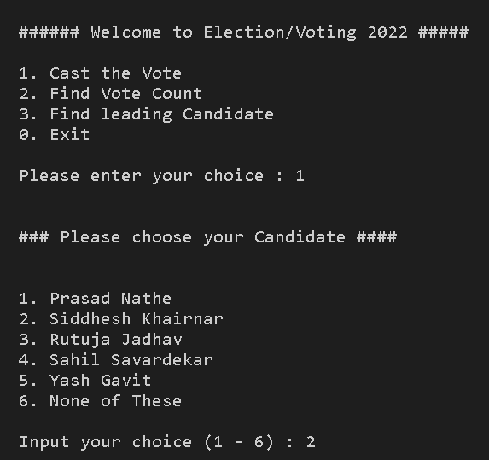 **1) Casting Vote: -**

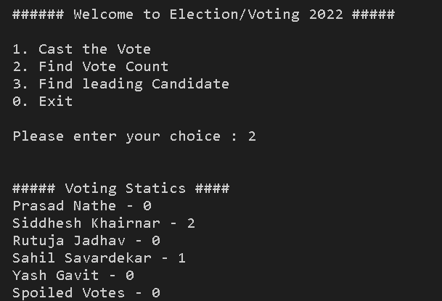**2)Finding Vote Count**

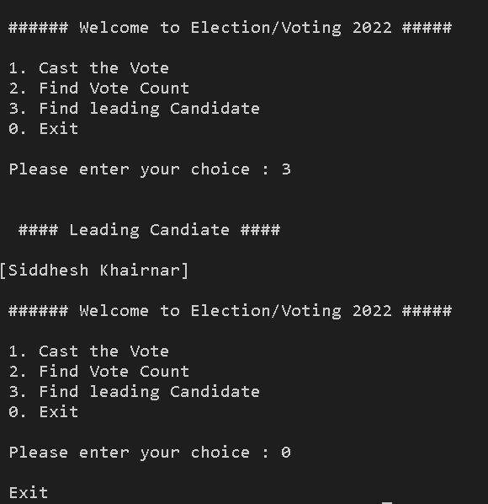**3)Finding Leading Candidate**

**LIST OF THE TOPICS/ CONCEPT WHICH ARE COVERED FROM THE SYLLABUS:**

1. Printf, scanf statements
2. If else statements
3. do while
4. Switch Case
5. Data types
6. Logical Operators
7. Arithmetic Operators
8. Relational Operators
9. Function calling

CONCLUSION: -

In conclusion, we want to emphasize that the program is not complete by itself. There is still a lot of room for improvement. There are many features that can be added in the program to make the users get maximum benefit.

This is an open-source program and therefore everybody is welcome to develop it. Future developers are very welcome to add their ideas to the program and improvise it.